CHANAKYA UNIVERSITY
[Department of Computer Science and Engineering]
________________________________________________________________
PROJECT REPORT
College Event Statistics Portal

Submitted By | Suhita Salaka  Punarvasu
Course / Subject | Computer Science and AI
Semester | 4th SEM
Academic Year | 2nd Year
Faculty Guide | Nitesh sir and Shivprasad sir
Submission Date | 2/05/2026

Abstract
The College Event Statistics Portal is a web-based solution designed to centralize event, participant and result management for academic institutions. The system supports coordinator login, event creation, participant registration, competition result entry and student search. It imports the university-provided OJAS 2K26 Excel participation data into normalized database tables and combines it with new records entered through the portal. The dashboard presents school-wise event statistics, category-wise participation, internal versus external participation, data-source distribution and a derived Department Engagement Score. The project demonstrates how Python, relational databases and analytics dashboards can convert scattered event records into useful institutional insights.

Table of Contents
No. | Section | Page
1 | Introduction, Objectives and Scope | 4
2 | System Architecture, Technology Stack and Requirements | 5
3 | Database Design and University Excel Import | 6
4 | System Modules, Dashboard and Data Processing | 7
5 | Implementation, Deployment, Testing and Conclusion | 8

Project at a Glance
Project Title | College Event Statistics Portal
University | Chanakya University
Students | Suhita Salaka, Punarvasu
Core Domain | Event management, data analytics and visualization
Application Type | Python web application with cloud database
Key Dataset | OJAS_2K26_student_list_synthetic-data.xlsx
Hosting | Render Free Web Service
Database | Neon PostgreSQL

Introduction
Colleges conduct technical, cultural, sports and co-curricular events across multiple departments or schools. In many cases, event details, participant records and result information are maintained in spreadsheets or informal documents. Such distributed records make it difficult for faculty, heads of departments and management to understand participation trends, active departments, event categories and student achievements.
The College Event Statistics Portal transforms event records into structured data and analytical insights. It supports academic reporting, event planning and data-driven review of student participation.

1. Introduction, Objectives and Scope

1.1 Objectives of the Project
The main objective of the project is to develop a centralized web portal that manages college event information and generates meaningful statistics from both imported university data and newly entered portal data.
- Provide authenticated access for coordinators or administrators.
- Maintain event, participant and competition result records in a normalized database.
- Import OJAS 2K26 Excel participation data and combine it with live portal entries.
- Generate dashboards for school-wise, category-wise and source-wise analysis.
- Demonstrate Python full-stack development, data cleaning, SQL design and deployment.

1.2 Scope of the Project
Covered | Not Covered | Assumptions / Limitations
Event creation, participant registration, result entry, Excel import, dashboards, student search and cloud deployment. | Advanced ERP integration, payment workflows, certificate automation and department-specific permission hierarchy. | Excel file does not contain confirmed dates and venues, so configurable defaults/placeholders are used for imported OJAS events.

1.3 Problem Statement
Manual event tracking creates fragmented records, duplicate student entries, inconsistent event names and limited visibility into institutional participation. Without a unified database and dashboard, stakeholders cannot easily determine which schools are active, which event categories attract more participation, or which students repeatedly contribute to college activities.

1.4 Proposed Solution
The proposed solution is a Python-based College Event Statistics Portal. It stores event data in a relational database, supports manual data entry through web forms and imports the university-provided OJAS 2K26 workbook into the same database. The dashboard then presents a consolidated view of imported and newly entered data.

1.5 Stakeholders
- Students: view participation history and event information.
- Coordinators: create events, add participants and record results.
- Faculty and HODs: analyze participation, event distribution and departmental engagement.
- Management: review college-level activity patterns and reporting indicators.

2. System Architecture, Technology Stack and Requirements
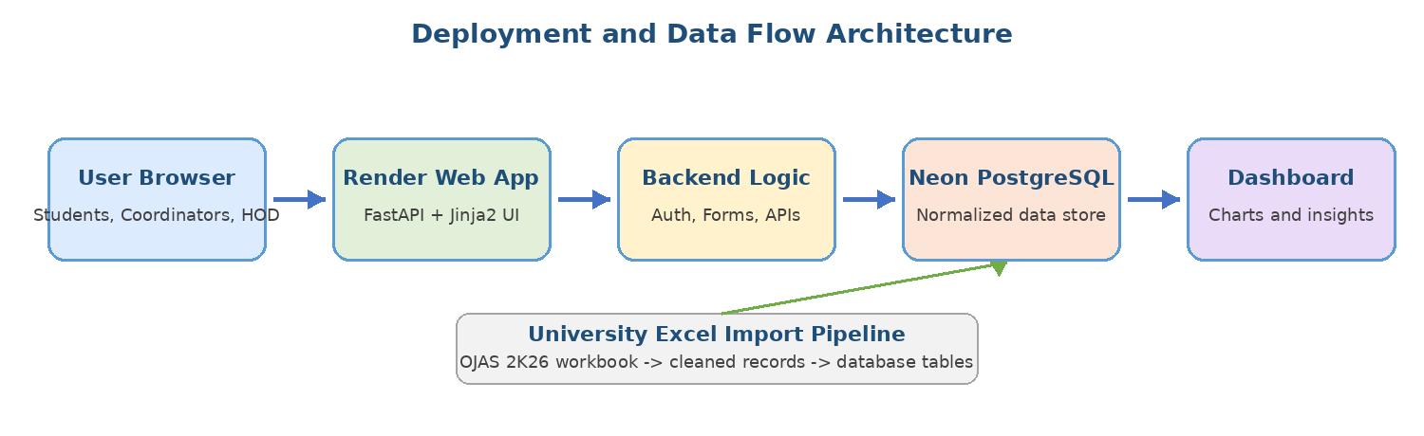

2.1 Architecture Explanation
The application follows a layered architecture. The user interface is served through Jinja2 templates and browser-based pages. FastAPI handles web routes, form processing, authentication, APIs and business logic. SQLAlchemy provides object-relational mapping with PostgreSQL. The Excel import pipeline converts OJAS 2K26 workbook rows into normalized database records. Chart.js renders dashboard visualizations using aggregated data from the backend.

2.2 Technology Stack
Technology | Purpose | Reason for Selection
FastAPI | Backend web framework | Fast, Python-based and suitable for APIs and web routes.
Jinja2 + HTML/CSS | Frontend pages | Simple, server-rendered UI appropriate for a student project.
Chart.js | Dashboard charts | Lightweight browser-based visualization library.
PostgreSQL / Neon | Cloud relational database | Supports SQL, relationships, constraints and analytics queries.
SQLAlchemy | ORM layer | Maps Python models to relational tables.
Pandas + OpenPyXL | Excel import and cleaning | Efficient processing of workbook data.
Render + GitHub | Hosting and source control | Public web app deployment from repository.

2.3 Requirement Analysis
Functional Requirements | Non-Functional Requirements
Login, event entry, participant entry, result entry, Excel import, dashboard filters, student lookup and analytical summaries. | Usability, cloud accessibility, data consistency, maintainability, secure credential handling and repeatable import processing.

3. Database Design and University Excel Import

3.1 Database Design
The database is designed as a normalized relational model. Instead of keeping all event and participant information in a single spreadsheet-like table, the system separates users, departments or schools, event categories, events, participants, participation records and competition results. This structure reduces duplication, improves update accuracy and supports analytical SQL queries.

Table | Purpose | Key Relationships
users | Stores coordinator/admin login accounts. | Created-by relation for events.
departments | Stores departments or schools. | Referenced by events and participants.
event_categories | Stores event category names. | Referenced by events.
events | Stores event metadata, source and competition flag. | Linked to departments, categories and participation records.
participants | Stores student or external participant details. | Linked through event_participants.
event_participants | Many-to-many association between events and participants. | Core fact table for analytics.
competition_results | Stores ranks, prizes and awards. | Linked to event participation.
data_imports / raw_import_records | Audit trail for Excel import activity. | Tracks source file and raw rows.

3.2 University Excel Data Import
The university provided the workbook OJAS_2K26_student_list_synthetic-data.xlsx. The workbook contains OJAS 2K26 student participation and registration data. Since the workbook is section-based rather than a flat table, the import logic identifies school rows, event rows and student rows, then transforms them into database records.
- School sections are mapped to department or school records.
- Event sections are converted into event records with source tracking.
- Student rows are converted into participant and event_participation records.
- Duplicate imports are avoided through source identifiers and existing-record checks.
- Raw import rows are stored for auditability and data-quality review.
Importing the Excel file into the database is preferable to reading the workbook directly in the dashboard. It ensures that imported data and manually entered data follow the same structure, are available to SQL queries and can be processed consistently for analytics.

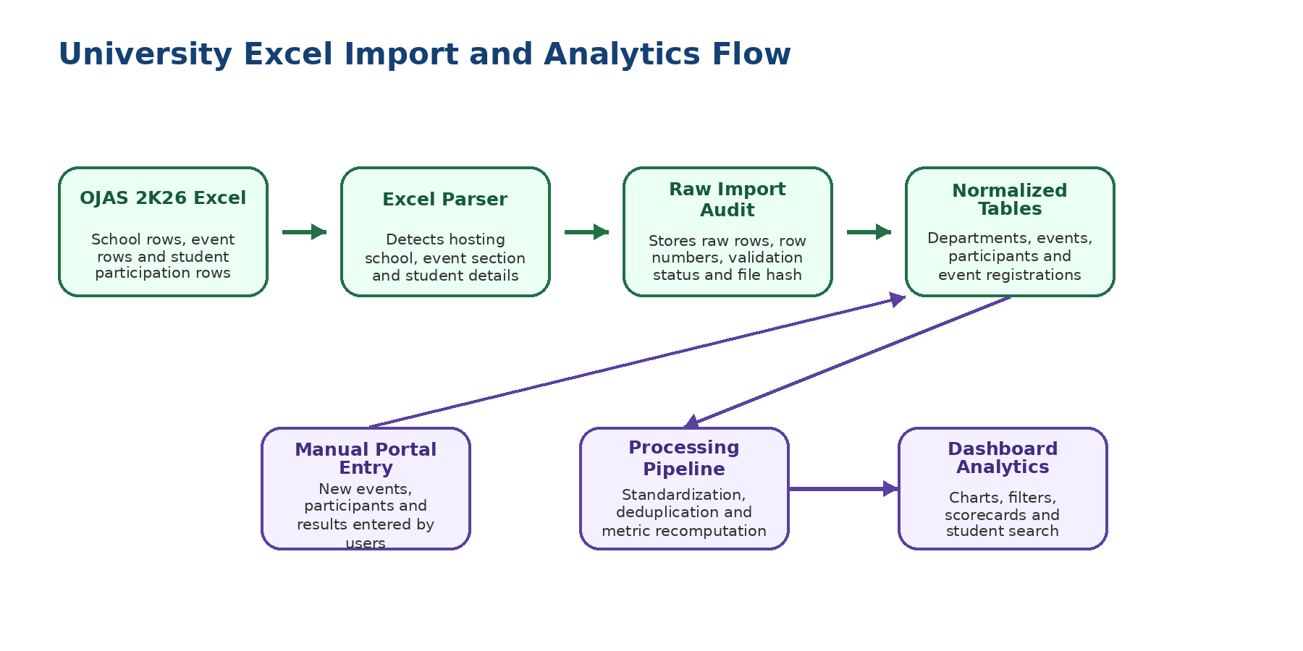

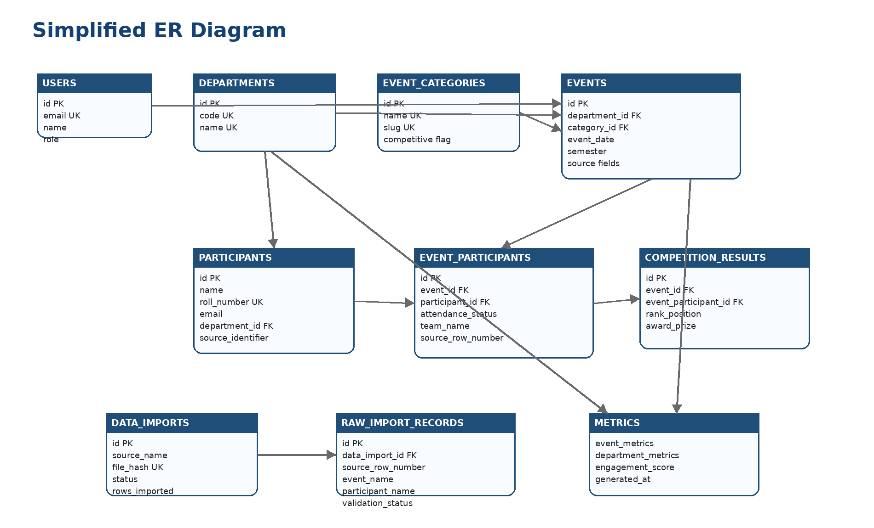

4. System Modules, Dashboard and Data Processing

4.1 Modules of the System
Module | Description
Login / Authentication | Coordinator or admin login with password hashing and protected data-entry actions.
Event Management | Creation and listing of events with department, category, date, venue, description and competition flag.
Participant Management | Entry of internal and external participants, including roll number, email, contact and school/department.
Competition Results | Recording of rank, prize or award for competitive events.
Excel Import | Conversion of OJAS 2K26 workbook data into normalized records with audit trail.
Dashboard and Analytics | Charts and summary metrics for event, participation, category and source analysis.
Student Search | Search by name, email, roll number or source identifier for participation history.

4.2 Dashboard and Analytics
The dashboard is the analytical layer of the system. It summarizes event and participation data using visual charts and key metrics. The dashboard combines imported Excel data and new portal-entered data, enabling a consolidated view of college event activity.
Metric / Chart | Purpose
School-wise event count | Identifies active schools or departments.
Category-wise participation | Shows which event types attract more participants.
Internal vs external participation | Distinguishes institution participants from outside participants.
Data source mix | Separates imported Excel records and manually entered records.
Monthly trends | Supports time-based review of event activity.
Department Engagement Score | Derived metric combining event activity, unique participants and result activity.

4.3 Data Processing and Cleaning
Python, Pandas and OpenPyXL are used to parse and clean workbook data. The processing standardizes names, email IDs, contact numbers, event labels and school names. The import pipeline is designed to be idempotent, meaning repeated execution should not create uncontrolled duplicates. Data quality is essential because inaccurate or inconsistent records directly affect dashboard results and institutional insights.
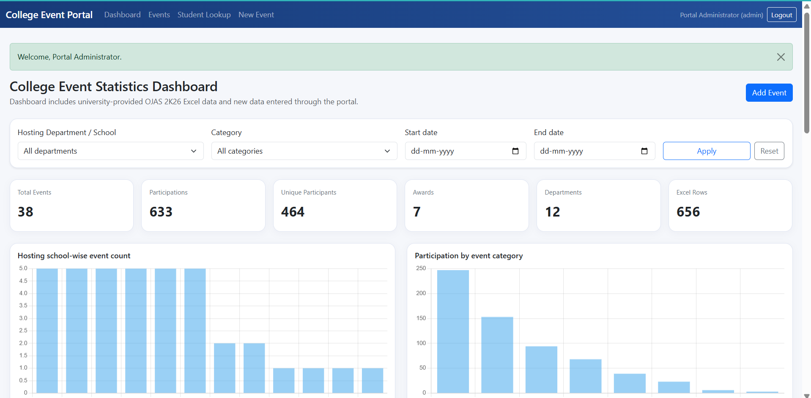

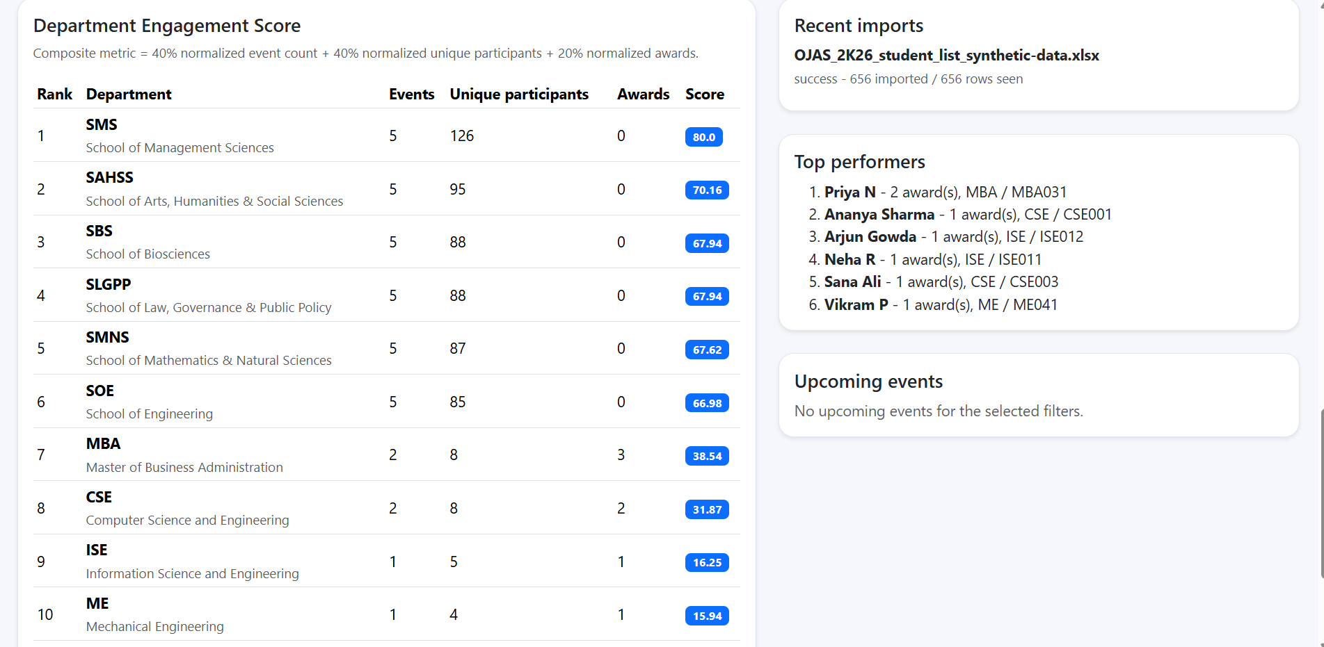

5. Implementation, Deployment, Testing and Conclusion

5.1 Implementation Details
The backend is implemented using FastAPI. Routes are defined for login, dashboard pages, event forms, participant forms, result entry and student search. SQLAlchemy models represent the relational schema and manage database operations. Jinja2 templates render the user interface, while Chart.js displays dashboard charts in the browser. Configuration values such as DATABASE_URL are stored as environment variables so that credentials are not hardcoded into source code.

5.2 Cloud Deployment
The application is designed for public demonstration through Render Free Web Service, while the database is hosted on Neon PostgreSQL. GitHub is used as the source code repository. This deployment model satisfies the assignment requirement that the project should be accessible through a public URL and connected to a cloud-hosted relational database.

5.3 Testing Summary
Test Area | Input / Action | Expected Result | Status
Login | Valid admin credentials | Dashboard access granted | Passed
Event Entry | Create new event | Event saved and listed | Passed
Participant Entry | Add participant | Participation linked to event | Passed
Excel Import | OJAS workbook import | Events and participants created | Passed
Dashboard | Open analytics page | Charts and metrics displayed | Passed
Deployment | Open Render URL | Public app loads successfully | Passed

5.4 Results, Advantages and Limitations
Results / Outputs | Advantages | Limitations
Working login page, event forms, participant entry, Excel import, dashboard, student search and cloud deployment. | Centralized data, reduced manual effort, combined imported and live data, better visibility and reusable database design. | Free hosting may sleep after inactivity; Excel file lacks actual dates and venues; advanced role permissions can be added later.

5.5 Future Enhancements and Learning Outcomes
Future enhancements may include department-level role-based access, certificate generation, email notifications, admin approval workflows, mobile optimization, PDF or Excel exports and integration with a college ERP system. Through this project, the students learned database normalization, Python full-stack development, cloud deployment, Excel data import, dashboard creation, data cleaning and teamwork.

5.6 Conclusion
The College Event Statistics Portal successfully addresses the need for a centralized event data management and analytics system. By combining university-provided OJAS 2K26 Excel data with new portal-entered records, the system demonstrates practical use of Python, PostgreSQL, data processing and visualization. The project satisfies the academic use case requirements and provides a strong foundation for future institutional event reporting systems.

References
FastAPI Documentation; PostgreSQL Documentation; SQLAlchemy Documentation; Pandas Documentation; OpenPyXL Documentation; Chart.js Documentation; Render Documentation; Neon Documentation; GitHub Documentation.

Appendix: Sample Analytics Formulas
Metric | Formula / Logic
Total Participation | Count of event_participants records
Unique Participants | Distinct participants linked to events
Engagement Score | Weighted score using event count, unique participants and result activity

